Documentation GL_TASK_1

GL_TASK_1 - Program for line-by-line text comparison.

**Buttons**

Description of buttons functionality.

Add file 1 - Button to add a text file to the left table.

Add file 2 - Button to add a text file to the right table.

Del row (left) - Button for deleting the selected row in the left table.

Del row (right) - Button for deleting the selected row in the right table.

Add row (left) - A button to add a blank line to the end of the left table.

Add row (right) - A button to add a blank line to the end of the right table.  
Compare files - Button for line-by-line text comparison.  
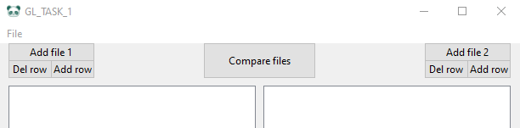

**Toolbar**

Description of the functionality of the toolbar buttons.

File:

Theme - Button to change the theme of the interface.

*There are three themes available: Ocean Blue, Valera, Tea with milk, def.*

Export to file - Button for exporting modified files.

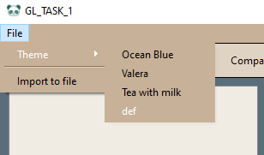

**Compare files**

Description of file comparison.   
If the rows are green, then the rows are the same; if the lines are red, then something is being distinguished in them.

